Team PostgreSQL

Topic: Business Description

**Description of the Chosen Business**

The prison facility database is built to manage important operational and administrative tasks related to inmates, staff, and facility operations. Key features include tracking inmate intake, managing sentence durations, keeping behavior records, logging health data, monitoring participation in rehabilitation programs, and organizing visitor logs. The system also keeps track of release dates and ensures prisoners are moved to the release history table when the time comes. These functions will help create a safer and more secure environment while making administrative work easier and supporting inmate rehabilitation.

The database is designed to handle large amounts of sensitive and confidential information with efficiency and accuracy. It is an important tool for administrative staff, security teams, and oversight agencies. The business situation of this database is that of a rehabilitation prison rather than a for profit prison. As such, none of our KPIs, views, or tables have anything related to the profit or budget of the prison.

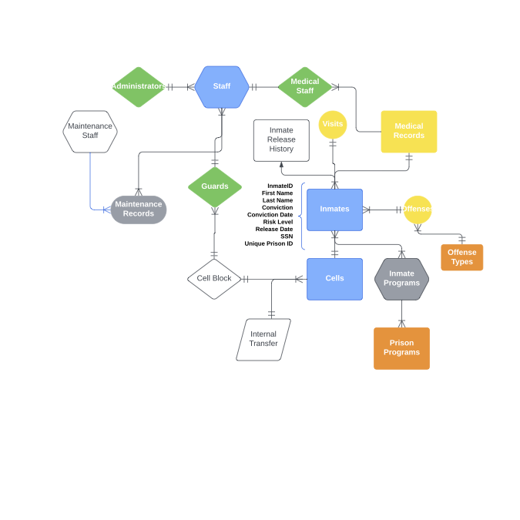

**Justification for the Choice**

Prisons generate massive amounts of data daily, and without an organized system, it’s hard to manage inmate profiles, track security incidents, and maintain accurate records for rehabilitation and medical care. A reliable database solves these issues by organizing data, making it easier to find, and providing detailed reporting tools.

This system supports the prison’s mission to maintain safety and help with rehabilitation while following legal standards. It allows staff to study inmate behavior, track involvement in programs, and monitor health issues, all of which are important for making progress. The database also saves time by reducing paperwork, so staff can focus on critical tasks. Using data effectively ensures the prison can meet regulations and adapt to new challenges.

**Strategic Goals**

**Enhance Security Protocols:** Use data to identify patterns in incidents and improve security measures.

**Improve Rehabilitation Outcomes:** Keep track of inmate participation in rehabilitation programs and use the information to make the programs more effective.

**Improve Organizational efficiency:** Ensure Prison is upheld to government and organizational standards. Ensure staff and inmates are organized and eliminate any inefficiencies.

**Reduce Reoffense Rates:** Create personalized rehabilitation programs and monitor post-release progress to help inmates successfully rejoin society.

**Tactical Goals**

**Strategic goals within the next 1-3 years:**

**Develop a Secure and User-Friendly Interface:** Build a database system that is easy for all departments to use while keeping sensitive information secure.

**Train Staff Across Departments:** Provide hands-on training to help guards, administrative staff, and healthcare teams input and access data effectively.

**Integrate Data Systems:** Link key areas like health records, incident tracking, and rehabilitation programs into one system to make workflows smoother.

**Operational Goals**

**​​Conduct Regular Audits:** Perform quarterly reviews to find and fix errors, protect data, and keep the database secure.

**Generate Monthly Reports:** Create detailed reports on inmate progress, program participation, security incidents, and health records to guide decisions and resource use.

**Monitor Program Effectiveness:** Track how well rehabilitation programs work and make changes if needed to improve outcomes.

**Ensure Data Accuracy**: Use strict checks during data entry to reduce errors and keep records reliable.

**Internal and External Analysis**

The database was created to fix problems inside the prison and meet outside expectations. Internally, it solves issues like disorganized records and poor communication between departments. Externally, it helps the prison follow government rules and meet the public’s demand for transparency and better rehabilitation programs.

**Alignment with Mission and Vision**

The prison’s mission is to keep the facility safe while giving inmates chances to rehabilitate and rejoin society. Its vision focuses on accountability, new ideas, and helping inmates succeed after release. This database supports these goals by keeping track of progress, organizing data, and helping staff make better decisions.